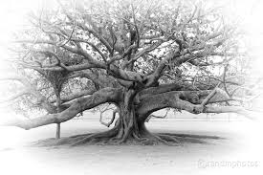
Mabel the Moreton Bay Fig Tree
Mathematical | Verbal | Visual/Spatial | Kinaesthetic | Musical | Interpersonal | Intrapersonal
I enjoy working with numbers and science | I enjoy reading, writing and speaking | I enjoy painting, drawing and visualising | I enjoy doing hands-on activities. | I enjoy making and listening to music | I enjoy working with others | I enjoy working by myself
Where are the oldest trees in the world? Create fact cards to show what you found out. | Prepare a talk about why Mabel should be saved. | Make a board game about mabel’s life. | Create a diorama of a scene from one of the tree stories that we have read in class. | View the tree song.  Write a song about Mabel and perform it for the class. | With a partner, write and present a comparison of Australian rainforests and South American rainforests. | Pretend that you are Mabel, (or a person who spent your life living near Mabel) write a series of diary entries about your life.
 | Write a poem about a tree. | Create a portrait of Mabel. | 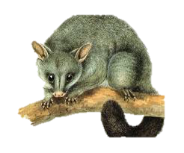 | Create a dance that tells the story about Mabel’s life. Perform it for the class. | Write a script of a conversation between Mabel and someone else. Perform it for the class. | 