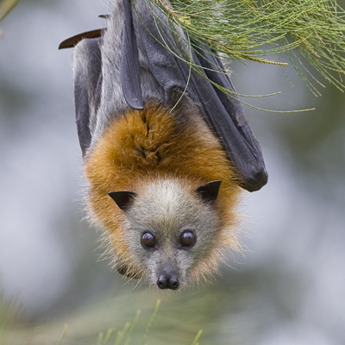
Dear Year Two Students of Good News,

My name is Fergus and I am a Grey-Headed Flying Fox.
I can’t thank you enough for writing back to Percy the Possum. All the animals that live here with Mabel are confident that you will help to make sure she is not cut down. We have given lots of information to your teacher, Mrs Eckermann, so that together you can discover why Mabel is such an important tree.
When I was a tiny pup clinging to my mum’s fur I used to listen to the colony telling stories about how they believe that it was a flying fox who brought the seed that became Mabel. You see, we flying foxes like to eat the figs that grow on trees like Mabel. The seeds stay whole in our bellies and they fall to the ground with our droppings. In this way, we help to spread the varieties of trees and other plants.
The Turrbal people lived here for thousands of years before any white settlers arrived. Instead of staying in one place and building homes, the Turrbal people moved around. See if you can find out why?
There were no GPS back then or even maps, instead the Turrbal people used songs to find their way around. A songline would be sung by grandparents to their grandchildren. The words of the songline told them where to find certain animals or trees or other useful things. Maybe one of the songlines told the people how to find Mabel and the other figs that grew here.
Like flying foxes, the Turrbal people ate Moreton Bay Figs, they also ground them up to make a paste to add to other foods. They used the sap of the tree to make a dressing to cover wounds a bit like a bandage. The inner bark of Moreton Bay Fig Trees could be used to make fine rope to create dilly bags and fishing nets. So I guess you could say that these trees were a bit like a supermarket for the aboriginal people.
I hope this letter helps you to understand another part of Mabel’s story.

From Fergus the Flying Fox
PS – We all loved the pictures on the top of your letters.

